PROPRIETARY & CONFIDENTIAL

Blauser Technologies
Micro MICR Systems

MMS & MMS-OC
Workstation Installation Instructions

Version 1.0
January 1, 2019

Table of Contents
1 Introduction 3
1.1 About This Document 3
2 Installation Process 3
2.1 Create Blauser Installs Folder 3
2.2 Download Workstation Installation ZIP Files 4
2.3 Check for Blocked File 4
2.4 Unzip to Blauser Installs 5
2.5 Running MMSSetup 5

Introduction

About This Document
This document contains installation instructions for the workstation releases of the Blauser Technologies Micro MICR Systems MMS and MMS-OC (Official Checks) software.
Workstation installations are required for computers that connect to a full installation of the MMS and/or MMS-OC software.
The Blauser Technologies’ workstation install is only used to register certain .dll and .ocx files with new Windows machines on your network. You must “register” the software with all your workstations that you are adding to your network if you need our software to run on those new PCs.
Blauser Technologies has two separate workstation installs. One for our MMS modules (loan coupons, personal and business checks, etc.) and one for our MMS-OC modules (Cashier’s checks, Official checks, Money Orders, etc.). For assistance with our workstation installs, please contact our support line at 888-500-6427.

Installation Process

Create Blauser Installs Folder
Prior to downloading either the MMS or the MMS-OC workstation zip files from our site, we recommend you create a “blauser install” folder on your network.
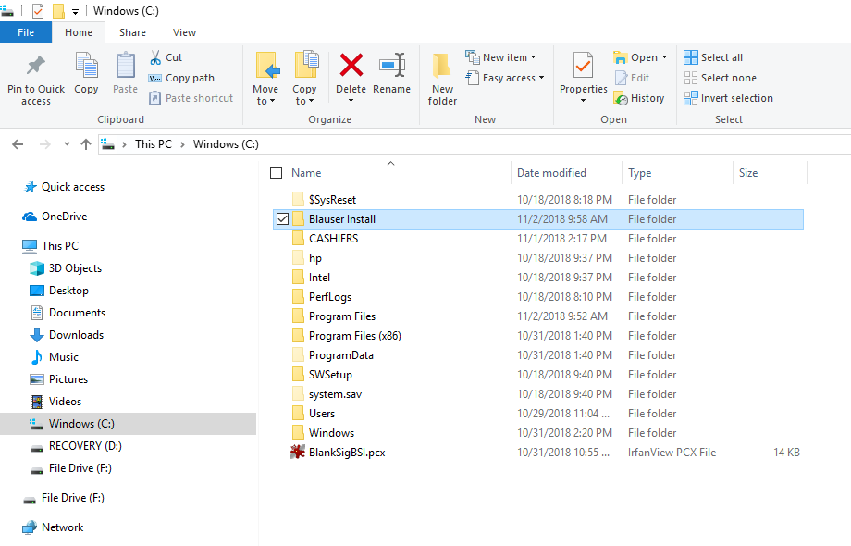

Download Workstation Installation ZIP Files
Download the files from the website as shown below:
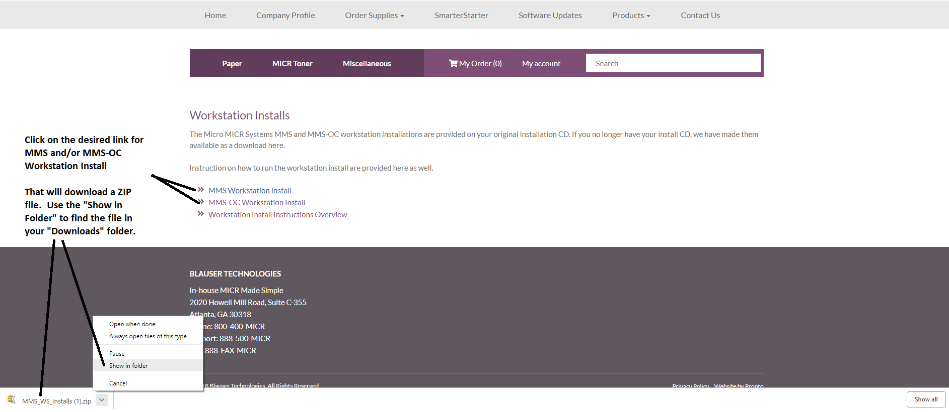

Check for “Blocked” File Attribute
Sometimes after the ZIP files are downloaded they will be marked as “Blocked” by Windows for security purposes. You can check if this is the case by right-clicking on the zip file(s) in the folder and looking at the properties.
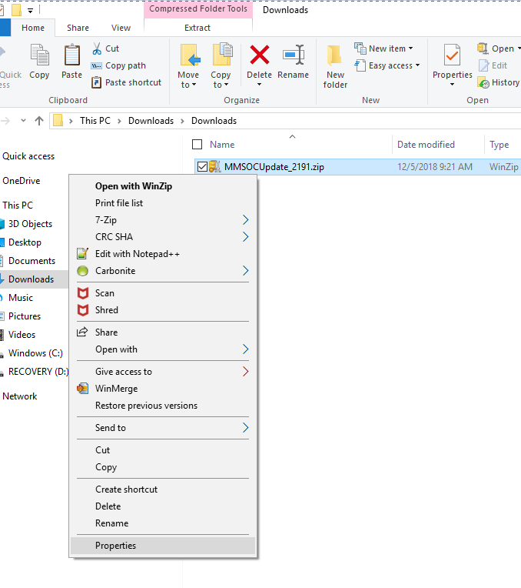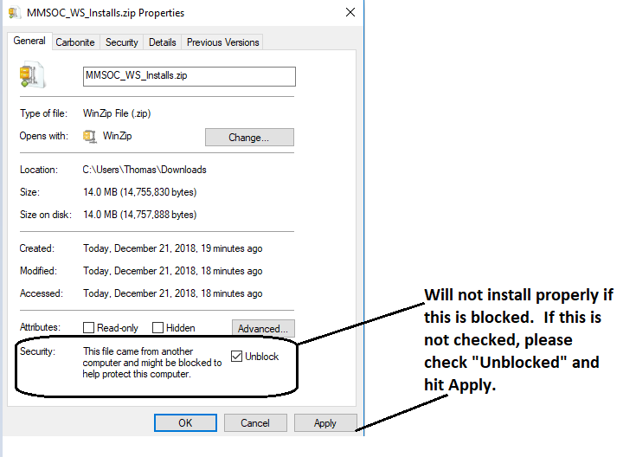

Unzip to Blauser Installs
Once the Blauser Installs folder is created, and you confirmed the files are not “blocked”, you can then extract all files into the new “Blauser Installs” folder. You will then have either one sub folder or both depending on your needs.
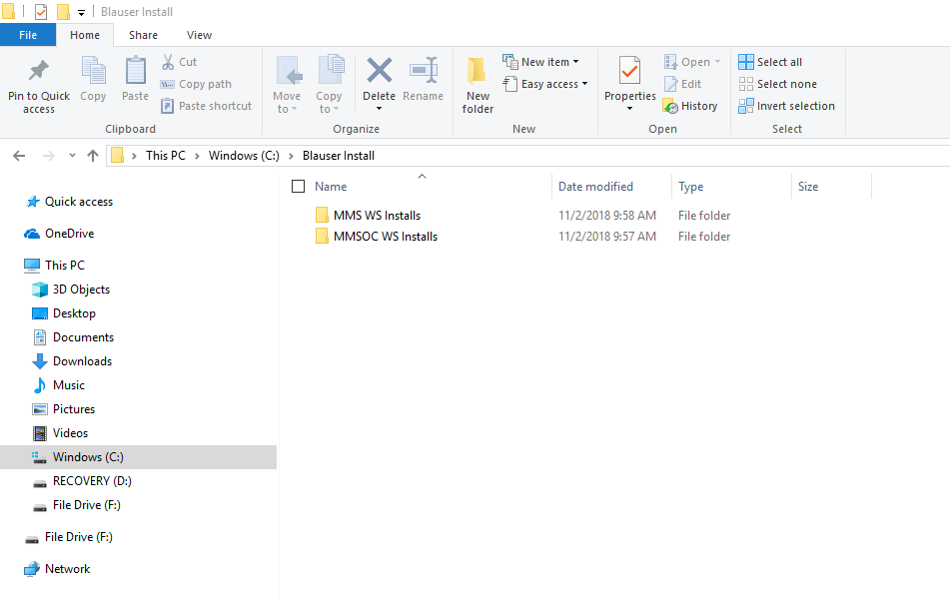

Run the Setup Processes
Once the directories are installed and unzipped, you will need to open the folder and run the MMSSetup.exe file to begin the workstation install.
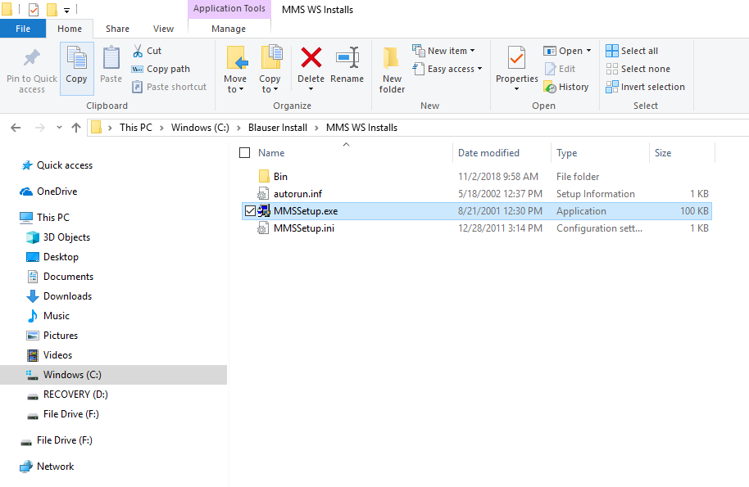

After selecting the “software Installation” menu choice.
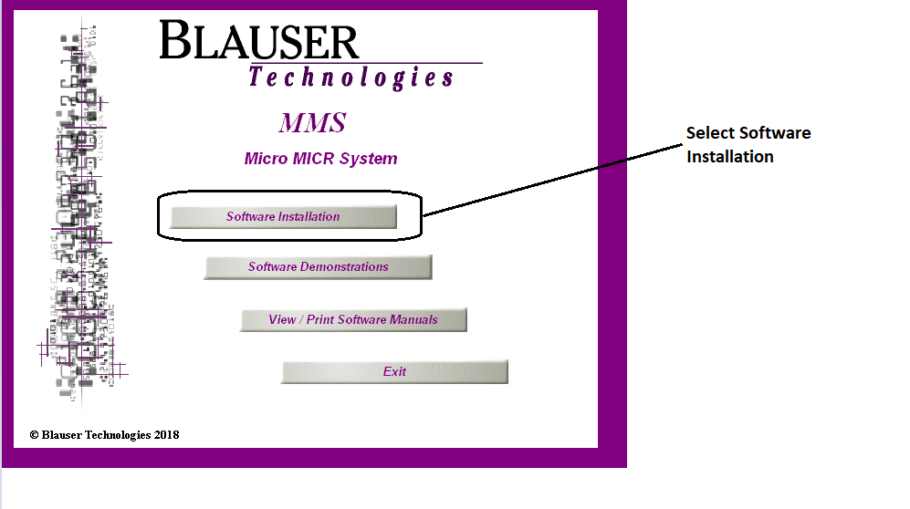
You must first accept the terms and conditions of the software.
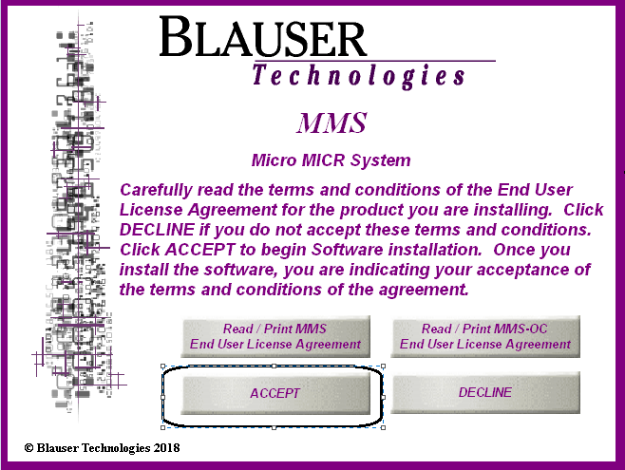
If you are running the MMS WS Install then the only option available to you is the MMS Workstation as shown below:
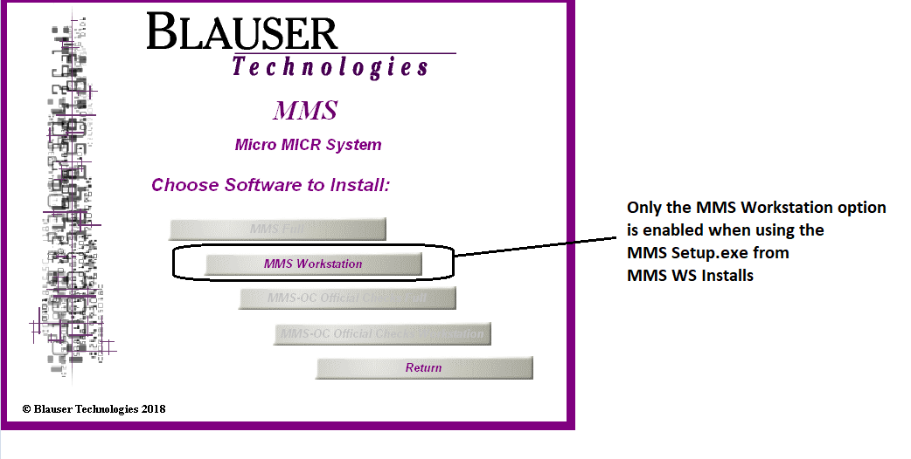
If you are running the MMSOC WS Install then the only option available to you is the MMSOC Workstation as shown below:
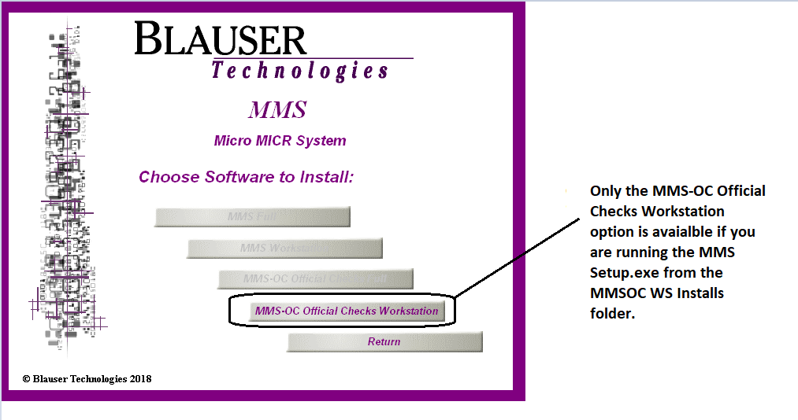
Next, click OK on the installation setup and choose the folder in which you want to install the workstation install.
It is recommended you maintain the defaults currently set up. Once you click install, you will be asked for a program icon group, choose the default, click OK and then select “yes” on all the files being copied that are not newer than the files currently on your system. Once complete, you have successfully completed your workstation install.
You will have to run this install on all your new PC that you are replacing. Once the installs are complete, you can create your short cuts from your server.

